Robert Johnson
51 W 105th St
New York NY 10025

Dear Rob,

The purpose of this letter is to confirm the following: You have kindly offered to provide Amazing Grace Movie LLC with the initial $250,000 to be paid to the Franklin Estate against my LLC’s contractual commitment to the Estate to pay it a guarantee of $1,100,000 for its rights associated with the film “Amazing Grace” and related materials. This letter will confirm my agreement with you that when any income, advances or payments are made to me or Amazing Grace Movie, LLC for distribution rights or other rights, I will direct on behalf of Amazing Grace, LLC and/or myself that the “first dollars” from any such payments will go directly to you until you are fully reimbursed for the $250,000 you provided for payment to the Franklin Estate.

Very truly yours,

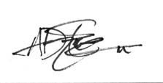
Alan Elliott, President and Owner of Amazing Grace Movie, LLC

